Name : Ida Bagus Ketut Yoghantara

Cohort : BDSE04-0322

**Assignment 1 – IA, Wireframe and Storyboard**

**1. Information Architecture**

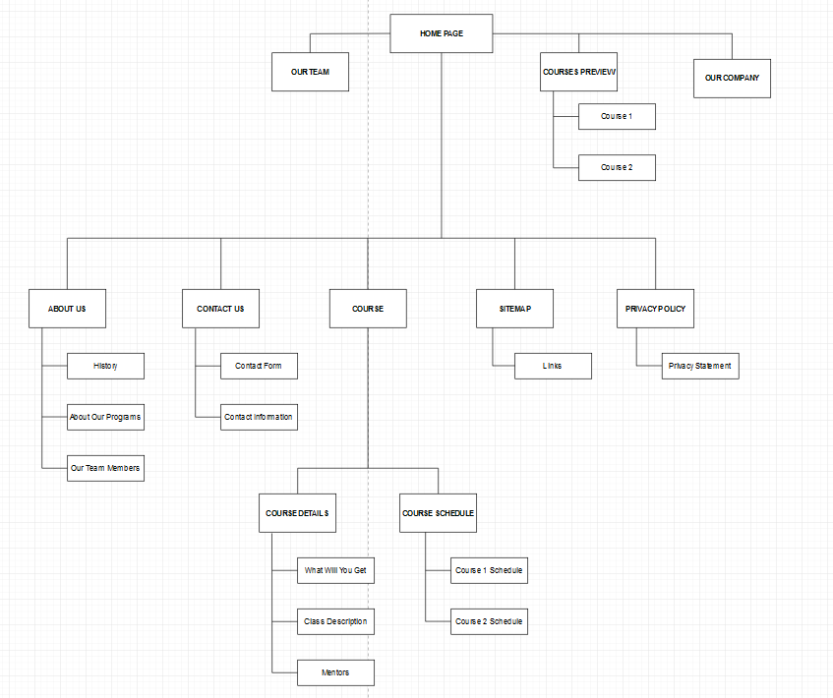

**2. Wireframe**

**Figma Link :**[**https://www.figma.com/file/PkhjM22ZXLLLg7ScEBGjXX/Gustut-Wireframe?node-id=0%3A1**](https://www.figma.com/file/PkhjM22ZXLLLg7ScEBGjXX/Gustut-Wireframe?node-id=0%3A1)

**Preview :**

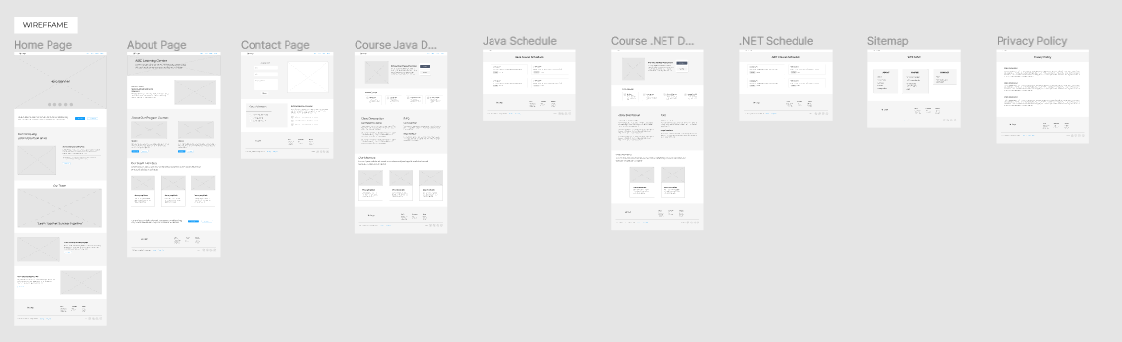

**3. Storyboard**

**Figma Link :**[**https://www.figma.com/file/PkhjM22ZXLLLg7ScEBGjXX/Gustut-Wireframe?node-id=0%3A1**](https://www.figma.com/file/PkhjM22ZXLLLg7ScEBGjXX/Gustut-Wireframe?node-id=0%3A1)

**Preview :**

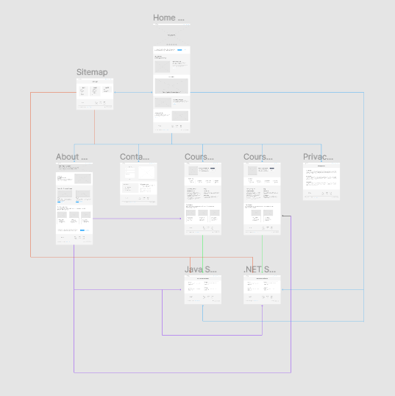

1. **Home Page**

This is home page it will contains ; hero banner, description about our company, our team picture, and preview to courses that we provide to our students. It will also have an image about our company building, and also provide links to all the web pages in the website.

1. **About Page**

About page describing more deeper to what is our company, the history of the company, about programs we provide, and profile to all of our team members.

1. **Contact Page**

Contact page contains contact form for anyone who want to contact to ask something regarding our company services. It will also provide our company contact information.

1. **Course Details**

We provide two courses, they are Java course and .Net programming language course. In this page is all about the course details and there also FAQ section for who that still confuse about the courses.

1. **Course Schedule**

Course schedule will be contain the schedule of our courses, anyone that still doesn’t register to our programs can look up to this section to seek the course schedule and how much hours or days or maybe months the course that they want to sign.

1. **Sitemap**

Sitemap will contain all the links to the every section of the website, so anyone who visit our website can searching what they need faster.

1. **Privacy Policy**

A privacy policy is a statement or legal document (in [privacy law](https://en.wikipedia.org/wiki/Privacy_law)) that discloses some or all of the ways a party gathers, uses, discloses, and manages a customer or client's data. Personal information can be anything that can be used to identify an individual, not limited to the person's name, address, date of birth, marital status, contact information, ID issue, and [expiry date](https://en.wikipedia.org/wiki/Expiration_date), financial records, [credit information](https://en.wikipedia.org/wiki/Credit_information), medical history, where one travels, and intentions to acquire goods and services.